
Instruction Guide

Lagaay Oxygen Bag
Product code: 204220

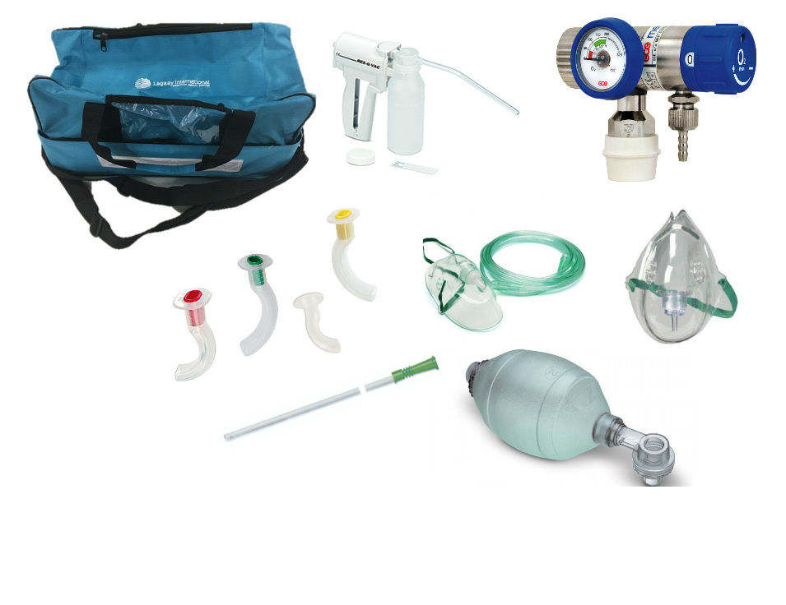

Read this instruction carefully
Please make sure that all personnel handling the product are provided with the operating instructions & performance data and are fully trained to carry out the operation.

Content

 | Oxygen cylinder 2 liter, 200 bar, bull nose or pin index connection | Product code: 204230 or 279750 | QTY: 1
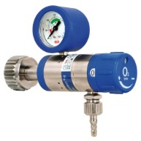 | Oxygen regulator, bull nose or pin index connection | Product code: 210710 or 248960 | QTY: 1
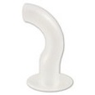 | Guedelairway, size 1 | Product code: 201390 | QTY: 1
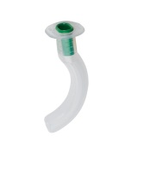 | Guedelairway, size 2 | Product code: 201400 | QTY: 1
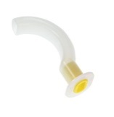 | Guedelairway, size 3 | Product code: 201410 | QTY: 1
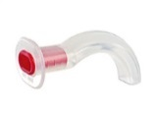 | Guedel airway, size 4 | Product code: 201420 | QTY: 1
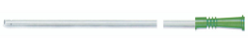 | Suction catheter, size CH12 | Product code: 202750 | QTY: 1
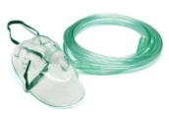 | Oxygen mask rebreathing adult | Product code: 246940 | QTY: 2
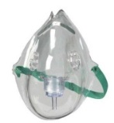 | Oxygen mask child | Product code: 246950 | QTY: 1
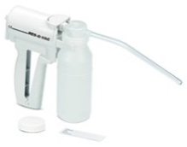 | Res-Q-VacHand suction unit | Product code: 210490 | QTY: 1
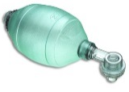 | Resuscitation bag white complete | Product code: 202910 | QTY: 1
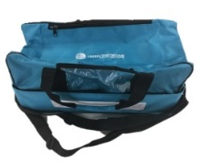 | Bag for oxygen set | Product code: 255755 | QTY: 1
 | Instructions for use oxygen set | Code: 275430 | QTY: 1
 | Check and renew document | Code: 295090 | QTY: 1
 | Proof of receipt and 1st check | Code: 999340 | QTY: 1
 | Certificate oxygen set | Code: 999080 | QTY: 1

Instruction Bullnose flow meter

Connecting the oxygen flow meter to the oxygen cylinder.
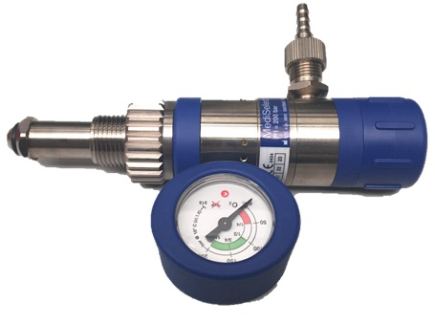
← 3. Flow outlet
← 4. Gauge
← 1. Flow head
2. Inlet nut
↓
a. Remove protection caps from inlet nut (2) and the yellow cap from the oxygen cylinder valve. Keep caps in a safe place for reuse during transport or storage.
b. Turn the knob on the flow in clockwise direction to make sure that the flow head (1) says “ZERO“.
c. Manually screw the inlet nut (2) onto the cylinder valve. Turn the regulator into the correct position for use and tighten the nut by hand – do not use any tools!
d. Connect the hose nipple to the flow outlet (3). Now you can connect any accessory to the hose nipple (oxygen masks, resuscitator inhalator, nebulizers).
e. Open the cylinder valve fully by turning the hand wheel anticlockwise .
f. Check the gauge (4) on the regulator to get a reading for the amount of oxygen in the oxygen cylinder.
g. Turn the knob of the flow head (1) to change the level of oxygen being released.

After use

a. Turn off the cylinder valve by turning the hand wheel in a clockwise direction to the stop position. Do not use excessive force.
b. Reset the flow head (1) on the “ZERO” position – when the gas venting has ceased.
c. Ensure the pressure gauge does not show any residual pressure.
d. Refit pressure outlet and flow outlet protection caps. Before refitting the caps, ensure they are clean.

Operating precautions

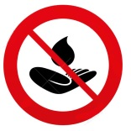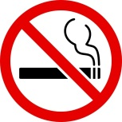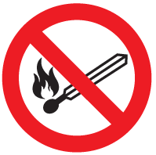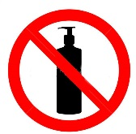
• Never permit oil and grease to come in contact with Oxygen cylinders, valves, regulators, gauges and fittings.
• Never use Oxygen from a cylinder without reducing the pressure through a suitable regulator intended for that purpose only. Stand to the valve side of the regulator when opening cylinder valve.
• Pressure regulators should never be changed by workers with greasy hands. Never test the pressure in an Oxygen cylinder by holding a gloved hand over the nozzle. An oil soaked glove may catch fire and cause the loss of one’s fingers or severe burns.
• If valve is difficult to open, point the valve opening away from you and use greater force. Avoid, however, the use of a wrench on valves equipped with hand wheels.
• Never permit Oxygen to enter the regulator suddenly. Open the cylinder valve slowly.
• Before regulator is removed from a cylinder, close the cylinder valve and release all gas from regulator.
• Avoid sparks or flame from welding or cutting torch coming in contact with cylinders.
• Fully open the cylinder valve when cylinder is in use.
• Oxygen must never be used to blow dust out of clothing or to freshen the air in closed places. This may cause explosive danger.
• Oxygen must be stored at least 20 feet from fuel gases such as Acetylene, Hydrogen, Methane, Propane, etc.

Instruction Lagaay Oxygen Bag

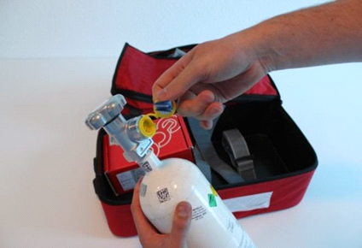 | 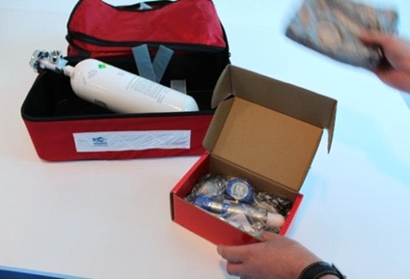
1 Remove yellow cap from valve | 2 Take out the flow meter
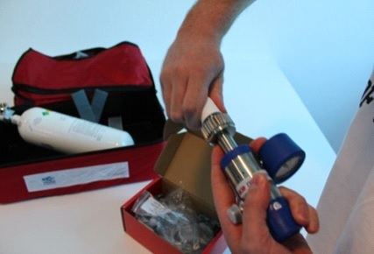 | 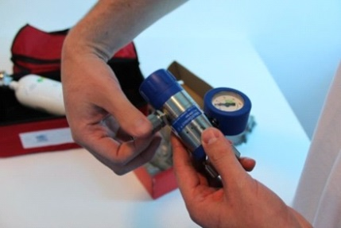
3 Remove protection caps | 4 Connect the hose nipple to the flow outlet
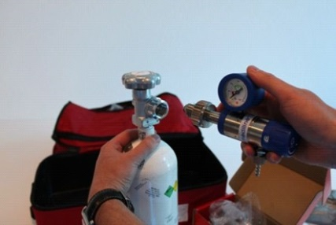 | 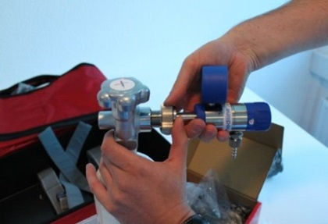
5 Connect the flow meter to the cylinder | 6 Manually screw the inlet nut to the oxygen valve
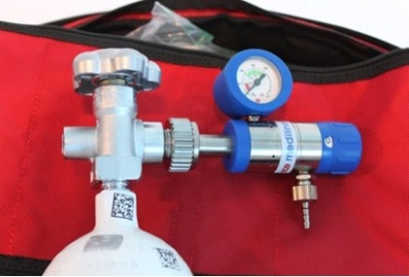 | 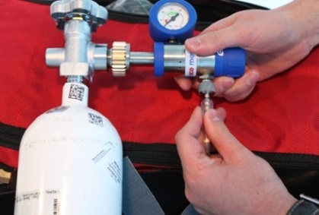
7 Ready for oxygen masks | 8 Connect the oxygen mask onto the hose nipple
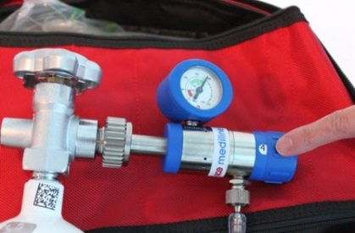 | 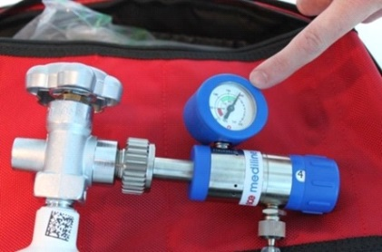
9 Set the oxygen flow using the knob of the flow head | 10 Read the right quantity of oxygen on the gauge

During emergencies
How to respond if the victim is still slightly breathing.
Use: Oxygen supply with inhalation mask
1. Slowly open the oxygen valve (turn to the left).
2. Connect oxygen tube of the inhalation mask to the outlet/nipple of the regulator.
3. Adjust the oxygen flow with one of the knobs at the front side of the regulator. Possible settings: Adults 6-6 ltr./min.
4. Clean the mouth and throat of the victim using your fingers or a cloth. Be aware of candy, chewing gum or vomit, etc.
5. Bend the head of the victim backwards, in order to clear the airway.
6. Place the inhalation mask over mouth and nose of the victim (narrow side on the nose and wide side on the chin).
7. Press slightly with your hand on the mask, avoid oxygen leakage, (patient exhales by himself).
8. When finished, close the oxygen cylinder and let the oxygen leave the system until the pressure gauge of the regulator indicates 0 m/bar. Turn the knobs of the flow regulator to the left till the indication o liters/minute.
9. Replace used masks.

How to respond in case the victim does not breathe independently.
Use: oxygen supply together with resuscitator.
1. Slowly open the oxygen valve (turn to the left)
2. Connect oxygen tube of the inhalation mask to the outlet/nipple of the regulator.
3. Adjust the oxygen flow with the knob at the front side of the regulator. Possible settings: Adult 6-8 ltr./min.
4. Clean the mouth and throat of the victim (narrow side on the nose and wide side on the chin).
5. Bend the head of the victim backwards, in order to clear the airway.
6. Place the mask of the resuscitator over the mouth and nose of the victim (narrow side on the nose and wide side on the chin).
7. Press slightly on the mask, i.e. to avoid leakage of oxygen during the resuscitation.
8. Use the other hand to squeeze the resuscitator slowly appr. 12-15 x per minute.
9. When finished, close the oxygen cylinder and let the oxygen leave the system until the pressure gauge of the regulator indicated 0 m/bar. Turn the knobs of the regulator to the left to the indication o liters/minute.
10. Clean used mask and resuscitator with mild liquid soap or by sterilizing.


Van Helmontstraat 99
3029 AA Rotterdam
The Netherlands

For inquiries about our products contact:
Telephone: +31 (0)10 412 38 71
Email: sales@lagaay.com
www.lagaay.com

