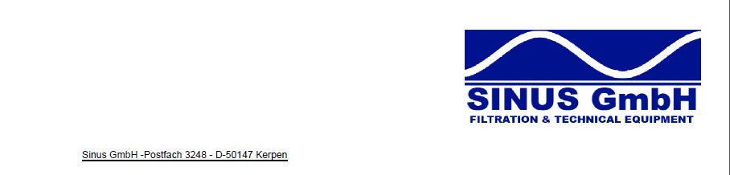
Information about Sinus GmbH
During the past few months Sinus has made a huge development. Sinus has hired new employees, extended their warehouse capacities and also its product range.
With the beginning of the summer in 2016 we will be moving our office including a much bigger warehouse.
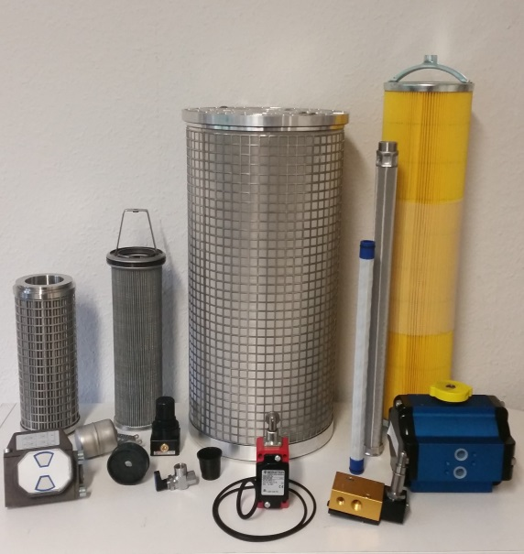
Therefore we would like to point out that from now on we are able to supply spare parts of the following manufacturers beside our present product range:
Automatic Filters:
BOLL&KIRCH
Alfa Laval MOATTI
KANAGAWA KIKI
YOOWON

FILTER FOR ENGINES:
MAN B&W
WARTSILA
CUMMINS
HYUNDAI HIMSEN

HYDRAULIC FILTER: OILY WATER SEPARATOR:
HYDAC RWO
PALL BLOHM&VOSS
FRAMO JOWA
EPPENSTEINER Mahle NFV

COMPRESSOR SPARES: Others:
ATLAS COPCO Aura Marine
TAMROTOR IMO
INGERSOLL RAND HVAC
KAESER SEA CHEST FILTER

... and many many more!

